Attendees – to be updated based on who dials in
Pauline Huynh | Yelena Shapiro, MedChi | Amalia Rivera Oven, MedChi | James Ting
Neha Anand | Kristan Baird | Ved Tanavde | Neel Koyawala
Lucy Nam | Jessica Lee | Alina Spiegel

Call to Order: 6:06pm
- Upcoming Dates: Reminder to download Google Calendar or put these dates in your calendar!
- Would anyone like to help with the activities fair? HAPP is meeting 8/2 at 6pm. Likely we will decide on a format for a common flyer to hand out during the fair then.
  - Hopkins Fair: August 9th - 4pm, Turner auditorium
  - Maryland Fair: Sept 19 last year - Jess to follow-up
  - USUHS Fair: August 16th - 1st year integration - Kristan will follow-up with date and will gauge interest about policy groups at USUHS joining HAPP
- Logos discussion (see below)
  - #1 - don’t know what the dome is, dome is confusing with Hopkins dome
  - #2 - not a fan of the swords and the logo
  - #3 - crab conveys Maryland but not the policy
  - #5 - simple, clean, maybe needs a border, MedChi could be darker bolder bigger, cartoon gives a pediatrics vibe
- What resolutions should we write for this Fall? Keep in mind that the Health Advocacy and Policy Partnership is interested in advocating for gun violence and opioid epidemic related resolutions in particular
  - Physicians - vast majority are supportive
  - Gun violence and opioid epidemic resolutions
  - Few high quality resolutions
- Two questions from Yelena
  - Next meeting? Will it be a social or regular meeting?
  - How many events and what kind? - budget/funding for next year
- Adjournment 8pm
RESOLUTION IDEAS:
- Gun Violence
  - Opposing armed campuses
  - Gun violence and mental illness - physicians should have an evidence based position
- Opioid Epidemic
  - FYI Medchi task force - http://www.medchi.org/ending-opioid-crisis
  - Supervised injection sites - MedChi supports efforts to pilot supervised injection sites
    - http://www.baltimoresun.com/news/opinion/oped/bs-ed-op-0419-consumption-sites-20180418-story.html
    - Link to PDF of article : http://docdro.id/GTHWAhZ
  - MedChi stances on prescription of buprenorphine and expansion of prescription
  - Newborn opioid addiction - child protective services

- Other
  - Policy finder - James
    - Existing archive
    - Gene guide us on best next step
  - NC bill - make prescription records available to police w/o warrant
  - ICE and Maryland - child separation
    - Precedent from the AMA
  - Affordable Housing - Mark Shi
- May be helpful to get notes on bills in past legislative sessions - institutional memory

Reference to some working documents – more detail in previous minutes
  - marketing / recruitment: Lucy working on logo; will work with HAPP to do joint recruitment
  - educate and empower members: Jack, Jess, James and Cara will head up legislative panel. Can also utilize MedChi staff to email legislators to help coordinate dates
  - Mentorship and physician relations: Alina and Neha to lead Speed Dating event

Student Section Logo. Here are options with feedback:
#1 dome unclear
#2 XXX
#3 policy not conveyed, crab confusing
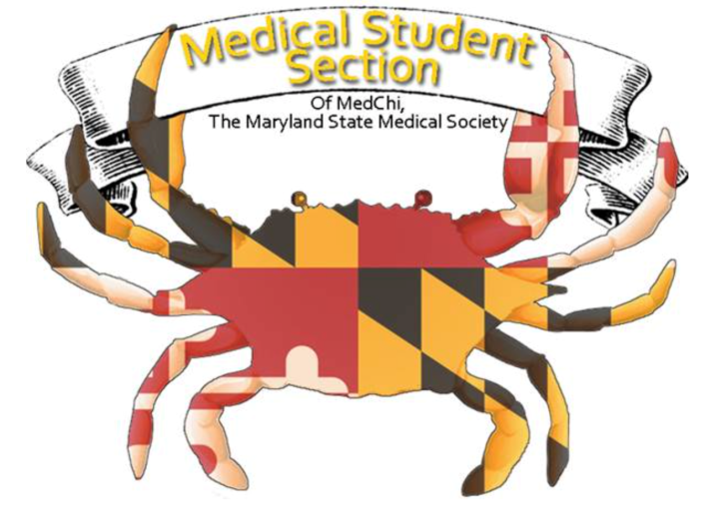
#4
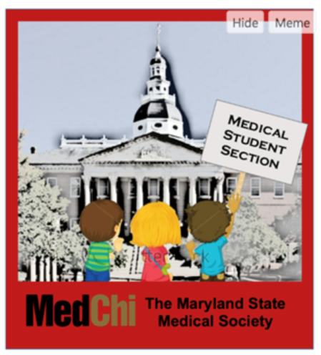
#5 box around, medchi bigger, pediatrics vibe,

#6 Gavel/flag cross
- cross/gavel on left and fonts on the right

Cross on left (Medchi logo now)
#7 just something off MEDCHI logo now
Maryland state medical society
- Right side put medchi and underneath “Medical student section” in nice font

